1. **Mallidi,Anudeep Reddy**
2. **Team D** – Phoenix
3. **Client**: Dr. Michael Oudshoorn (oudshoorn@nwmissouri.edu)
4. **Project**: Slack/Hip chat collaboration tool
5. **Team Role**: Quality and testing management
6. **Weekly Iteration plan**:

I have been assigned the role of Quality and testing management for this project. I am responsible for handling quality and testing throughout the SDLC process. I will be managing test cases and providing appropriate deliverables for the test modules. This week I am behind the schedule. I need to finish writing test cases for “Roles to team members”. It may not impact the progress of the project but has to be done by the end of this week.

Labor hour estimate: Planning to work around 39 hours this week and get my work done.

1. **Last week accomplishments**:

Last week I worked for 37 hours and I have designed moqups for our project and started working on the test cases for “Roles to team members”. I have created a moqup for user signup and login page and a moqup for logging in through google account. I also have designed a moqup to show how shared calendar in our project looks like. Here are the images 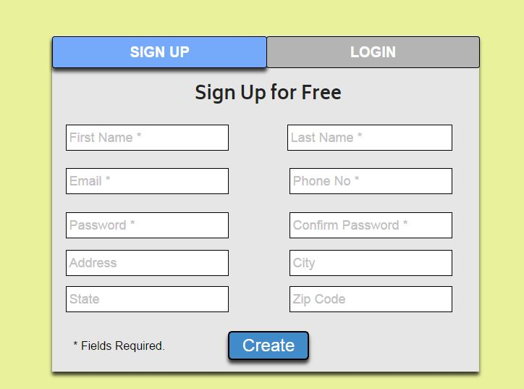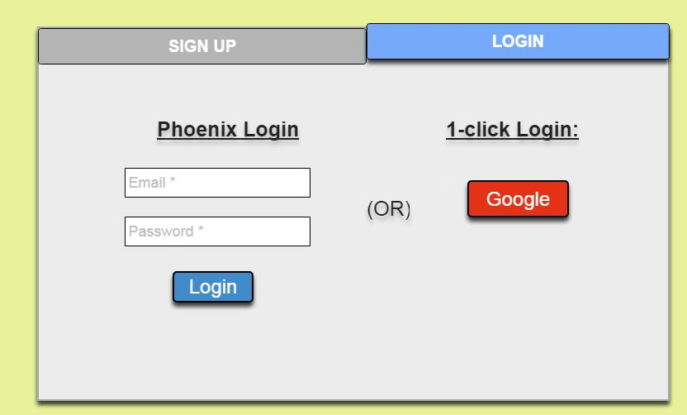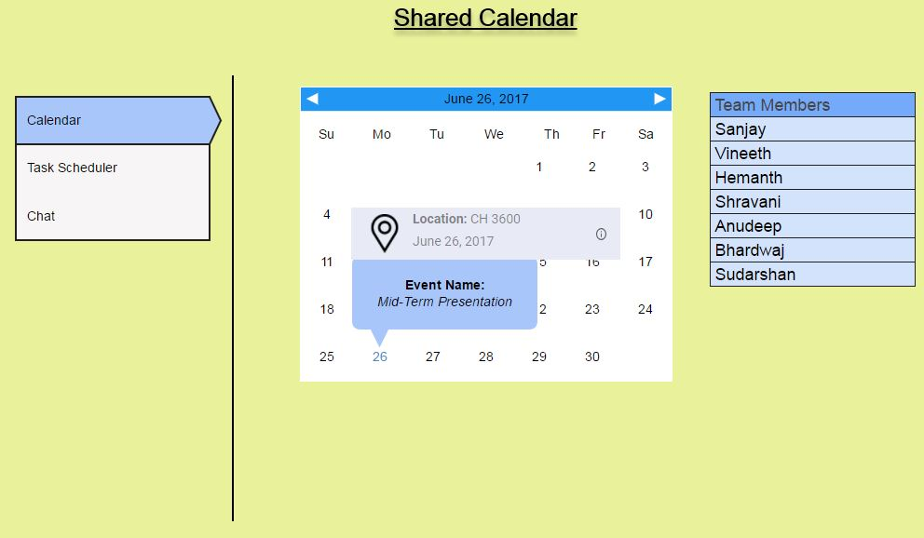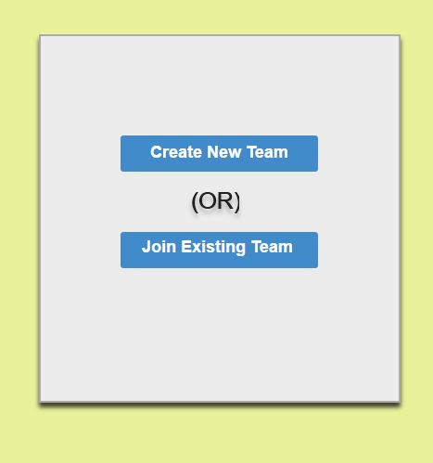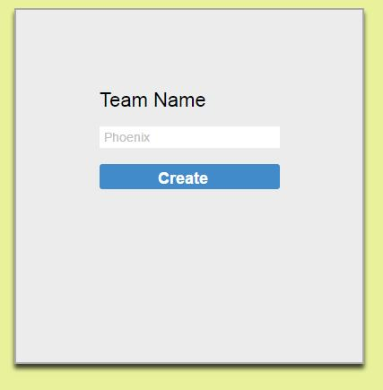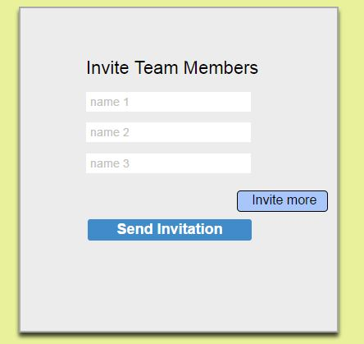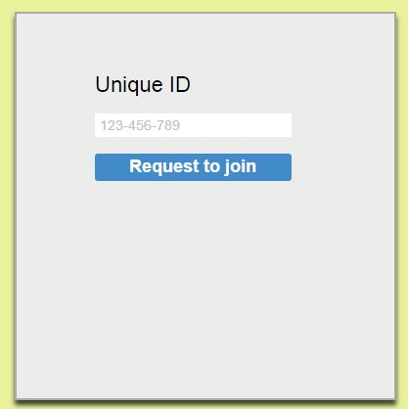

I also have gone through the client audio notes recorded by me for finalizing the requirements. Attached is a screenshot of the client audio notes

**Tasks to complete this week:**

* Will be working on designing software architecture
* Will be doing the effort distribution
* Need to do research on issuing different levels of control over the application.
* Will be finishing the use case diagrams and test cases for “roles to team members”.

**8.a copy of a complete post from one week ago**

**Mallidi, Anudeep Reddy**

**Team D** – Phoenix

**Client**: Dr. Michael Oudshoorn (oudshoorn@nwmissouri.edu)

**Project**: Slack/Hipchat collaboration tool

**Team Role**: Quality and testing management

**Weekly Iteration plan**:

I have been assigned the role of Quality and testing management for this project. I am responsible for handling quality and testing throughout the SDLC process. I will be managing test cases and providing appropriate deliverables for the test modules. This week I would like to analyze the feasibility of the requirements provided by the client and discuss with my team what actions are possible and also discuss the analyzed feasibilities.

Labor hour estimate: Planning to work around 15 hours this week and get my work done.

**Last week accomplishments**:

Last week I worked around 13 hours on collecting requirements and choosing the right platform for the project. I have attended client meetings and concentrated mainly on client requirements and expectations for the project. I have created an account in hipchat and got an idea of how that collaboration tool works.

I have completed around 1-2% in collecting the requirements from the client and also had meetings with my team to gather more requirements to take this project on track.

**What is the riskiest component under development?**

The riskiest component is gathering the appropriate requirements for this project.

**What active efforts are most critical for client acceptance or GDP completion?**

The requirements gathered and its analysis would be most critical for client acceptance.